1. Operational Database Design

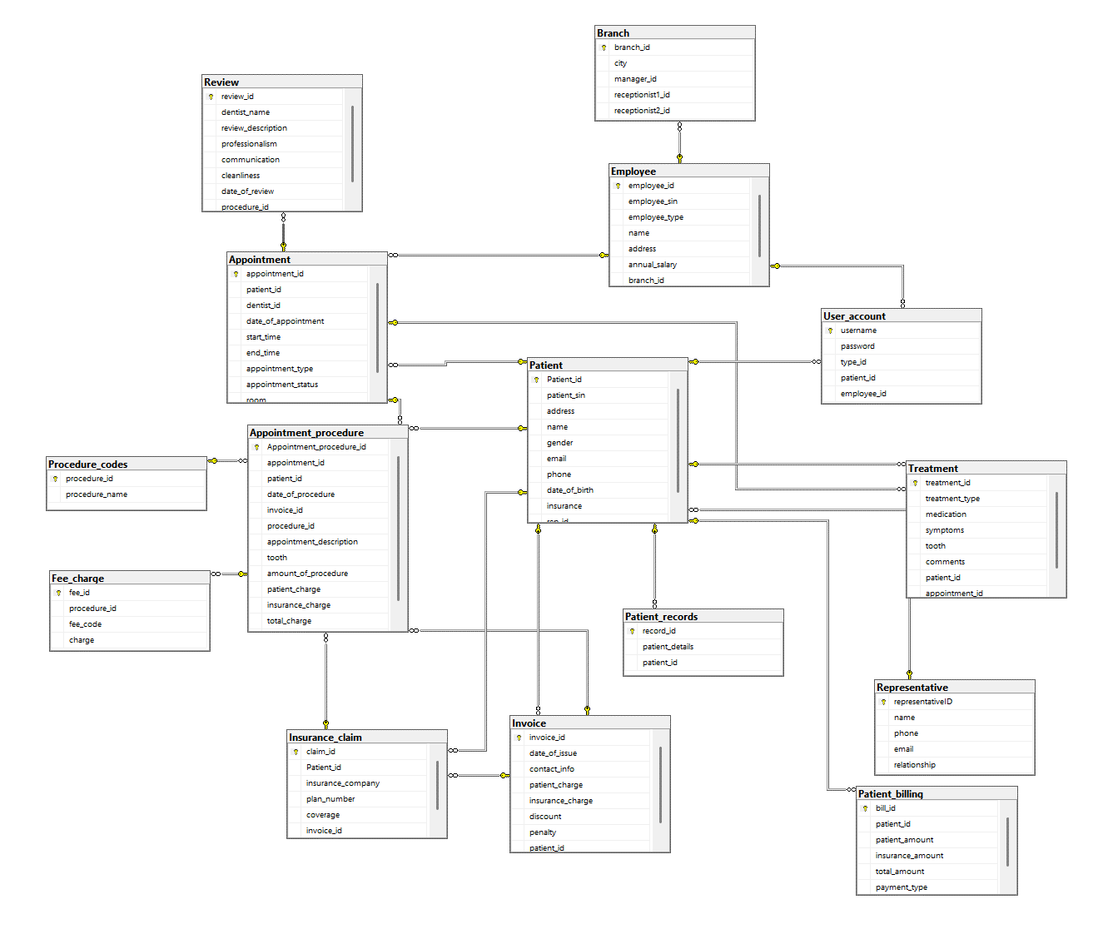

1. Table descriptions
   1. Table ‘User_account’

|  |  |  |  |  |  |  |  |
| --- | --- | --- | --- | --- | --- | --- | --- |
| # | Field name | Type | Unique | Auto Incremental | Not null | PK/FK | Note |
| 1 | Username | varchar |  | x | x | PK |  |
| 2 | Password | varchar |  |  | x |  |  |
| 3 | Type_id | smallint |  |  |  |  | 1 = employee  0 = patient |
| 4 | Patient_id | int |  |  |  | FK |  |
| 5 | Employee_id | int |  |  |  | FK |  |

* 1. Table ’Branch’

|  |  |  |  |  |  |  |  |
| --- | --- | --- | --- | --- | --- | --- | --- |
| # | Field name | Type | Unique | Auto Incremental | Not null | PK/FK | Note |
| 1 | Branch_id | int |  | x | x | PK |  |
| 2 | city | varchar |  |  | x |  |  |
| 3 | manager_id | int |  |  |  | FK |  |
| 4 | Receptionist1_id | int |  |  |  | FK |  |
| 5 | Receptionist2_id | int |  |  |  | FK |  |

* 1. Table ‘Employee’

|  |  |  |  |  |  |  |  |
| --- | --- | --- | --- | --- | --- | --- | --- |
| # | Field name | Type | Unique | AI | Not null | PK/FK | Note |
| 1 | Employee_id | int |  | x | x | PK |  |
| 2 | Employee_sin | int |  |  |  |  |  |
| 3 | Employee_type | varchar |  |  | x |  | “r” = receptionist  "d” = dentist  “h” = hygienist  “b” = branch manager |
| 4 | name | varchar |  |  | x |  |  |
| 5 | address | varchar |  |  | x |  |  |
| 6 | Annual_salary | numeric |  |  | x |  |  |
| 7 | Branch_id | int |  |  | x |  |  |

* 1. Table ‘Patient’

|  |  |  |  |  |  |  |  |
| --- | --- | --- | --- | --- | --- | --- | --- |
| # | Field name | Type | Unique | Auto Incremental | Not null | PK/FK | Note |
| 1 | Patient_id | int |  |  | x | PK |  |
| 2 | Patient_sin | int |  |  |  |  |  |
| 3 | address | varchar |  |  |  |  |  |
| 4 | name | varchar |  |  |  |  |  |
| 5 | Gender | varchar |  |  |  |  | “x” = Other  “F” = Female  “M” = Male |
| 6 | email | varchar |  |  | x |  |  |
| 7 | phone | varchar |  |  |  |  |  |
| 8 | Date_of_birth | date |  |  |  |  | <15 years old req_id is notnull |
| 9 | insurance | varchar |  |  |  |  |  |
| 10 | Rep_id | int |  |  |  | FK |  |

* 1. Table ‘Treatments’

|  |  |  |  |  |  |  |  |
| --- | --- | --- | --- | --- | --- | --- | --- |
| # | Field name | Type | Unique | Auto Incremental | Not null | PK/FK | Note |
| 1 | Treatment_id | int |  | x | x | PK |  |
| 2 | Treatment_type | varchar |  |  | x |  |  |
| 3 | medication | varchar |  |  | x |  |  |
| 4 | symptoms | varchar |  |  | x |  |  |
| 5 | tooth | int |  |  | x |  |  |
| 6 | comments | varchar |  |  | x |  |  |
| 7 | Patient_id | int |  |  | x | FK |  |
| 8 | Appointment_id | int |  |  | x | FK |  |

* 1. Table ‘patient_record’

|  |  |  |  |  |  |  |  |
| --- | --- | --- | --- | --- | --- | --- | --- |
| # | Field name | Type | Unique | Auto Incremental | Not null | PK/FK | Note |
| 1 | Record_id | int |  |  | x | PK |  |
| 2 | Patient_details | text |  |  | x |  |  |
| 3 | Patient_id | int |  |  | x | FK |  |

* 1. Table ‘Patient_billing’

|  |  |  |  |  |  |  |  |
| --- | --- | --- | --- | --- | --- | --- | --- |
| # | Field name | Type | Unique | AI | Not null | PK/FK | Note |
| 1 | Bill_id | int |  | x | x | PK |  |
| 2 | Patient_id | int |  |  | x | FK |  |
| 3 | Patient_amount | numeric |  |  | x |  |  |
| 4 | Insurance_amount | numeric |  |  | x |  |  |
| 5 | Total_amount | numeric |  |  | x |  |  |
| 6 | Payment_type | varchar |  |  | x |  | Accept only: Mastercard, Visa, Amex, Cash/Debit |

* 1. Table ‘Appointment’

|  |  |  |  |  |  |  |  |
| --- | --- | --- | --- | --- | --- | --- | --- |
| # | Field name | Type | Unique | AI | Not null | PK/FK | Note |
| 1 | Appointment_id | int |  | x |  | PK |  |
| 2 | Patient_id | int |  |  |  | FK |  |
| 3 | Dentist_id | int |  |  |  | FK |  |
| 4 | Date_of_appointment | date |  |  |  |  |  |
| 5 | Start_time | time |  |  |  |  |  |
| 6 | End_time | time |  |  |  |  |  |
| 7 | Appointment_type | varchar |  |  |  |  |  |
| 8 | Appointment_status | varchar |  |  |  |  | Accept only: Booked, Completed, Cancelled, No Show |
| 9 | room | int |  |  |  |  |  |

* 1. Table ‘Appointment_procedure’

|  |  |  |  |  |  |  |  |
| --- | --- | --- | --- | --- | --- | --- | --- |
| # | Field name | Type | Unique | Auto Incremental | Not null | PK/FK | Note |
| 1 | Appointment_procedure_id | int |  | x | x | PK |  |
| 2 | Appointment_id | int |  |  | x | FK |  |
| 3 | Patient_id | int |  |  | x | FK |  |
| 4 | Date_of_procedure | date |  |  | x |  |  |
| 5 | Invoice_id | int |  |  |  | FK |  |
| 6 | Procedure_id | int |  |  |  | FK |  |
| 7 | Appointment_description | varchar |  |  | x |  |  |
| 8 | tooth | int |  |  | x |  |  |
| 9 | Amount_of_procedure | int |  |  | x |  |  |
| 10 | Patient_charge | numeric |  |  |  |  |  |
| 11 | Insurance_charge | numeric |  |  |  |  |  |
| 12 | Total_charge | numeric |  |  | x |  |  |
| 13 | Insurance_claim_id | int |  |  |  | FK |  |

* 1. Table ‘Fee_charge’

|  |  |  |  |  |  |  |  |
| --- | --- | --- | --- | --- | --- | --- | --- |
| # | Field name | Type | Unique | Auto Incremental | Not null | PK/FK | Note |
| 1 | Fee_id |  |  | x | x | PK |  |
| 2 | Procedure_id |  |  |  | x | FK |  |
| 3 | Fee_code |  |  |  | x |  |  |
| 4 | charge |  |  |  | x |  |  |

* 1. Table ‘Insurance_claim’

|  |  |  |  |  |  |  |  |
| --- | --- | --- | --- | --- | --- | --- | --- |
| # | Field name | Type | Unique | Auto Incremental | Not null | PK/FK | Note |
| 1 | Claim_id | int |  | x | x | PK |  |
| 2 | Patient_id | int |  |  | x | FK |  |
| 3 | Insurance_company | varchar |  |  | x |  |  |
| 4 | Plan_number | int |  |  | x |  |  |
| 5 | coverage | numeric |  |  | x |  |  |
| 6 | Invoice_id | int |  |  | x | FK |  |

* 1. Table ‘Invoice’

|  |  |  |  |  |  |  |  |
| --- | --- | --- | --- | --- | --- | --- | --- |
| # | Field name | Type | Unique | Auto Incremental | Not null | PK/FK | Note |
| 1 | Invoice_id | int |  | x | x | PK |  |
| 2 | Date_of_issue | date |  |  | x |  |  |
| 3 | Contact_info | varchar |  |  | x |  |  |
| 4 | Patient_charge | numeric |  |  | x |  |  |
| 5 | discount | numeric |  |  | x |  |  |
| 6 | penalty | numeric |  |  | x |  |  |
| 7 | Patient_id | int |  |  | x | FK |  |

* 1. Table ‘Procedure_codes’

|  |  |  |  |  |  |  |  |
| --- | --- | --- | --- | --- | --- | --- | --- |
| # | Field name | Type | Unique | Auto Incremental | Not null | PK/FK | Note |
| 1 | Procedure_id | int |  | x | x |  |  |
| 2 | Procedure_name | varchar |  |  |  |  |  |

* 1. Table ‘Representative’

|  |  |  |  |  |  |  |  |
| --- | --- | --- | --- | --- | --- | --- | --- |
| # | Field name | Type | Unique | Auto Incremental | Not null | PK/FK | Note |
| 1 | RepresentativeID | int |  | x | x | PK |  |
| 2 | name | varchar |  |  |  |  |  |
| 3 | phone | varchar |  |  |  |  |  |
| 4 | email | varchar |  |  |  |  |  |
| 5 | Relationship | varchar |  |  |  |  |  |

* 1. Table ‘Review’

|  |  |  |  |  |  |  |  |
| --- | --- | --- | --- | --- | --- | --- | --- |
| # | Field name | Type | Unique | Auto Incremental | Not null | PK/FK | Note |
| 1 | Review_id | int |  | x | x | PK |  |
| 2 | Dentist_name | varchar |  |  |  |  |  |
| 3 | Review_description | varchar |  |  |  |  |  |
| 4 | Professionalims | int |  |  |  |  | Accept only: 0 -> 5 |
| 5 | Communication | Int |  |  |  |  | Accept only: 0 -> 5 |
| 6 | Cleanliness | Int |  |  |  |  | Accept only: 0 -> 5 |
| 7 | Date_of_review | Date |  |  |  |  |  |
| 8 | Procedure_id | int |  |  | x | FK |  |